EX:7 Unification and Resolution – Exercises with Solutions
Query:
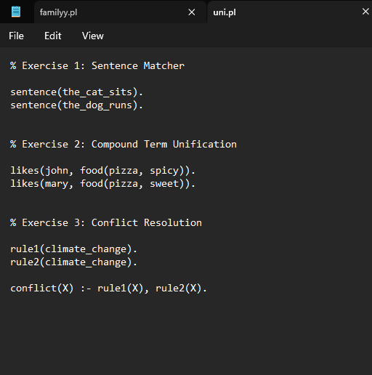
Output:
